First name Last name
Title of Thesis
Metropolia University of Applied Sciences
Master of Engineering
Information Technology
Master’s Thesis
1 March 2022

PREFACE

A Preface is optional but highly recommended. In this page you may use informal language such as “This study was a long and hard journey for me but it is done now … finally!” Remember that after this preface you are not allowed to use informal language and do not use “I” or “You” etc. in the coming sections (see below).

“I this thesis I studied …” should be something like “This thesis includes a study …”

A Preface, which is typically about half a page long, includes:
- challenges you faced while writing the thesis
- things you learned
- acknowledgments for those who helped you to do your thesis (colleagues, instructor, family, friends, pets ….)

Location, Date
Your Name
Abstract
Author: First Name Last Name
Title: Title of the Thesis
Number of Pages: xx pages + x appendices
Date: 1 March 2021
Degree: Master of Engineering
Degree Programme: Information Technology
Professional Major: Networking and Services or Medical Technology
Supervisors: First name Last name, Title (e.g. Project Manager)
First name Last name, Title (e.g. Principal Lecturer)

Abstract is a brief (one page) summary of the whole study. It should include:
- a couple of sentences for background info (if needed)
- what was the problem you tried to solve
- why it was important to solve it
- how you solved it
- scope of the study (also what was left out)
- key results and findings

Use past tense to refer to what you did (“was created”, “was tested” …) and the present tense to refer to your written report (“The results of the thesis show that ...”). This applies also to the upcoming sections.

See one example in the Thesus database:
http://urn.fi/URN:NBN:fi:amk-201605117147

Keywords: keyword, keyword

The originality of this thesis has been checked using Turnitin Originality Check service.

Contents
List of Abbreviations
1 Introduction 1
2 Method and Material 4
2.1 Research Design 4
2.2 Reliability and Validity 6
3 Current State Analysis / Project Specifications 7
3.1 Tables 7
3.1.1 Number of Subheadings 9
3.1.2 Two Subheadings Needed 9
3.2 Quotes 9
3.3 Lists 9
3.4 Listings 10
3.5 Formulas 10
4 Theoretical Background 12
5 Results and Analysis 13
6 Discussions and Conclusions 14
7 Summary 15
References 16
Appendices
Appendix 1: Appendix name
Appendix 2: Appendix name

List of Abbreviations
This is always needed. List the abbreviations in an alphabetical order. When you introduce an abbreviation for the first time in the text, use the following practise: “The Base Station Controller (BSC) is responsible for …”.
3GPP 3rd Generation Partnership Program
4G Fourth Generation (mobile network)
Abis, ABIS Abis interface in GSM network between the BTS and the BSC
AF Assured Forwarding
BCF Base Control Function
BCFSIG BCF signalling (link)
BCSU Base Station Controller Signalling Unit
BE Best Effort
BFD Bidirectional Forwarding Detection
BSC Base Station Controller
You may also include a short description of the abbreviation and make the list as following:
3GPP 3rd Generation Partnership Program. A collaboration of telecommunication associations and companies which makes standards for mobile networks.

Introduction
A typical structure of a thesis was shown in the table of contents. Please remember that titles in English are in most cases written with Capital Letters in Each Word (except for prepositions and and/or) and no articles a/an/the are used. The following sections give brief guidelines as to what to include in those sections, how figures etc. should be presented and also some hints for proper, academic English.
Write the introduction of your thesis here. Use Body text style for normal text. Likewise, use styles Heading 1, Heading 2, and Heading 3 for headings. As you apply the predefined styles, the text will automatically format correctly: the line spacing will be 1.5, both edges will be justified, and the text will be hyphenated.
The last line of a paragraph can be left hanging, that is, it does not have to reach the right margin. Begin a new paragraph at the left margin, that is, do not indent the first line. Remember also that a paragraph should always include at least two sentences, typically little more.
The introduction is the most important section of your thesis (the next one is Discussion and Conclusions). It should be written on a general level and include the following:
- Introduce the subject and put it into the framework of general knowledge.
- Describe briefly the company (who has ordered the study).
- State the “problem” you are going to solve and how you plan to reply it (i.e. what is the objective of your study). If possible, try to create a clear understandable research question: “This research evaluates the potential security risks related to the new network architecture proposed for the company X. Especially it tries to answer the following research question: What actions should the company X do before taking into use the new network architecture to meet the given security targets?”.
- Explain why it is important to solve this problem.
- Explain how you are going to solve the problem, see also next section (Method and Material).
- Present the scope of the study (what is included, what is not included and why).
Please remember that you cannot copy-paste your research plan here. The research plan is in most cases written in the future tense, whereas your thesis is a report of a study you have already conducted, thus, past tense.
Notice that the introduction does not mention the results of the thesis and does not summarize the whole thesis. Similarly, it typically does not discuss theory nor make references to sources as it is supposed to be the student’s own text.
At the end of the introduction, describe the structure of the report shortly by stating what each section includes: “This thesis has been divided into 6 sections. The first section introduces the problem …”.
Next main level section should start from new page (use Insert -> Page Break to make sure it starts from a new page).
Thesis Process
Once your thesis has been approved and stored in Wihi-system, you will be assigned with a thesis instructor. Agree with your instructor how you proceed with the thesis work, an example process is listed below:
- Write a draft Table of Contents and agree a meeting with your instructor. It is much easier to discuss about your thesis once the Table of Contents exists.
- Send your thesis to the instructor in small pieces, one or two sections at a time. This way your instructor can comment and redirect (if needed) your thesis in the early phase.
- Remember that AI-tools can not be used to generate text, but they can be used as a consultant to collect ideas. All thesis works are checked with the Turnitin test, which also checks if the text has been generated with some AI tool.
- Also, send your text as you have written it, do not use any tool to improve the English language. After the thesis has been checked by the Turnitin, the language can be improved with some tool.
Hints for English Language

The following reminders are mostly for Finnish writers of academic English, others may have a look at them too, though.

- Avoid using ‘I’, ‘we’, ‘our’ etc. throughout your thesis. If you wish to say, for instance: “I chose this topic because…” a better way would be expressing it as follows: “This topic was chosen…”
- Never use the personal pronoun ‘you’ in a thesis.
- Write words such as ‘is not’, ‘will not’, ‘does not’ separately.
- Words such as ‘first, second, main, last’ etc. always require a definite article ‘the’.
- Whenever possible, replace the colloquial ‘like’ with ‘such as’ or ‘e.g.’. Similarly, avoid everyday expressions such as ‘a lot of’ (instead, use ‘many, numerous, a number of, a great deal of’), ‘hard’ (use ‘difficult’ or ‘demanding’ instead) and ‘there is/there are’. For example, if you wish to say ‘There are a lot of companies specialized in network architecture’, a better way to express this would be: ‘Many companies specialize in network architecture’. The general idea is to avoid everyday expressions and wordiness.
- Try make your text more convincing by avoiding the ‘main clause, main clause, main clause’ structure.
- Try to include connecting or linking words to the text, as they are very characteristic of academic writing in English.
- It is often better to use ‘the’ instead of this, that, these or those.
- Avoid expressions considered too unsophisticated in reporting:
  - has/have -> contain/s
  - was done -> was carried out/was conducted
  - get (results) -> obtain (results)

Method and Material
A recommended way to start a new section is to describe with a couple of sentences what is included in that section: “This section introduces first the method used in this study and then….” No future tense (will) is used here. Metatext such as this is an integral part of any academic or scientific writing.
In an engineering thesis this section may sometimes be left out and the content is integrated to the Introduction section. This applies to cases where for example some new SW or a prototype was developed and tested. If, however, the research method and/or used material plays an important role in the study then it is good to have a separate section for them.

Research Design
There must always be text below each heading. Do not place a figure or table below a heading with no text in between. Label each figure and table appropriately. Provide a number, caption and reference (if needed) below each figure (see Figure 1). Remember to mention each figure in text, telling the reader what they are supposed to see in it.
If subheadings are used, there should be at least two of them. And remember that each paragraph should include at least two sentences.
Below one example of research design (or plan). With that type of a figure one can easily visualize the structure of the study.
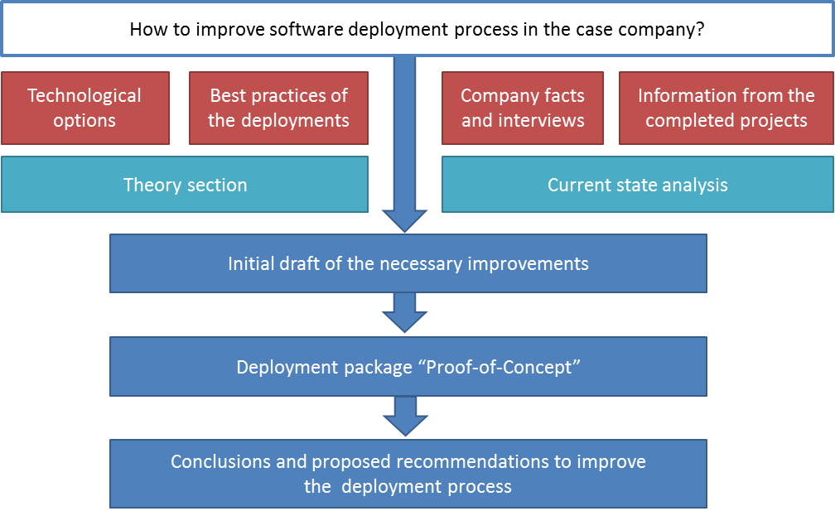
Figure 1. Research Design.
An auto-numbered figure caption is inserted by right clicking the figure and selecting Insert caption. Type the caption in the opening dialogue window. Figure 2 shows how to enter the caption.
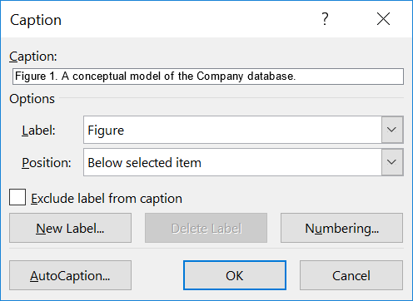
Figure 2. Entering the figure caption.
If the names of the built-in styles appear in a language other than English, you can change the default language of the Office package. To do this, select Office and Graphics / Office 2016 Language preferences from the operating system’s Windows menu, and choose English as the editing language.
If you have copied the figure, please remember to add a reference after the figure text “Figure 2. Market share of cloud service providers. [2]” The [2] comes Vancouver referencing style, see References at the end of this document.
Note also that there should always be text between a figure or table and a new figure or table or a new heading.

Reliability and Validity
One challenging issue for most of the studies is how to justify the results. The results and conclusions of the thesis should be reliable and not dependent on the person who conducted the study. So, when you plan and do your study, try to be as objective as possible and avoid using your own (potentially biased) opinions about the subject.

Current State Analysis / Project Specifications
This section first introduces the current IT-system architecture of company X ….
Current State Analysis (CSA) should focus on the analysis of the present state of your chosen topic, not the whole case company. The CSA is carried out in order to detect the key weaknesses regarding the identified problem or current solution (for instance something is not working right) and highlight the areas where an improvement is needed. Thus, this section describes in more detail the research question/problem already briefly explained in the Introduction, now based on an analysis carried out in the case company. Once the CSA results are known, the student will know what theory will be beneficial for coming up with a solution. For instance, if the CSA reveals that the main weakness with the current system at the case company is a usability problem, the theory section will focus on theory on usability.
Typically, this section does not include any theory, and thus no sources are used in this section, except perhaps for case company website or other company documents.
Note: Not all studies have a current state analysis (for example when you design a prototype for some new application). In that case, this third section may include your project specifications (unless they have been covered already in Introduction). If the analysis of the current state is the main focus of your thesis (and it is clear beforehand what technical background is required), then the sections of Current State Analysis and Theoretical Background should be changed.

Tables
There must always be text or a new subheading below each heading. Do not place a figure or table below a heading with no text in between.
Table 1 shows an example of a table created with Word. Use “Table content” style to achieve the tighter spacing used in the tables. Also, place a caption above each table.
Table 1. Mean execution times of the selected sorting algorithms in the two scenarios.
Algorithm | Mean execution time (scenario 1) | Mean execution time (scenario 1)
Bubble sort | 1,420 ms | 13,700 ms
Quicksort | 175 ms | 548 ms
Insertion sort | 1,080 ms | 9,300 ms

Figure 3 displays how to create a caption above the table. The dialogue window appears by clicking on the square-shaped table selector near the top left corner of the table and selecting “Insert caption”.
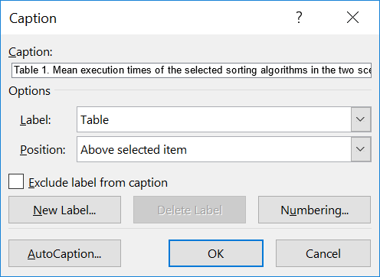
Figure 3. Entering the data for table caption.
When a table caption has been created, change its style to Table caption.

Number of Subheadings
Try to avoid third level subheading as the table of contents may become very long and never user fourth level subheadings. An alternative solution is to just add a headline as normal text (i.e. no subheading). This works especially well if the “subheadings” are very short.

Two Subheadings Needed
This is just to remind you, that if you add a subheading, there should be at least two subheadings at that level (in this case 3.1.1 and 3.1.2). Remember also that there should be at least two paragraphs under each subheading …. so this is too short subheading.

Quotes
Quotes use the “Quote” style. The paragraph containing the citation passage (immediately before the citation) uses the “Body Text Before a Quote or List” style to leave a shorter paragraph spacing between the citation and the passage.
Direct quoting uses the “Quote” style of the template. A citation is given in the quotation.
After indentation, the text continues from the left edge in the “Body text” style.

Lists
A list in the text uses the “List” style. The paragraph before a list uses the “Body text before a quote or list” style.
When the list items are not sentences, they begin with a lowercase letter, and the last list item ends in a period. The thesis consists of:
- words
- clauses
- sentences
- paragraphs
- chapters.
When the list items are sentences, they begin with a capitalized letter, and the list items end in a period:
- This is the first item in the list.
- The second item of the list here contains a long text that spans multiple lines. The left edge aligns automatically.
- This is the third item in the list.
- The fourth item in the list is here.

Listings
A listing displays source code of a computer program (listing 1). Use “Code line” style to mark code lines, and create indentations with the Tab key. The caption should follow the “Listing caption” style.
def inventory():
cur = db.cursor()
sql = "SELECT Description FROM OBJECT WHERE Location='PLAYER'"
cur.execute(sql)
if cur.rowcount>=1:
print("You carry the following items:")
for row in cur.fetchall() :
print (" - " + row[0])
else:
print("You don't carry anything.")
return
- A Python subroutine that outputs information about objects in possession of a player.

Formulas
You can insert numbered formulas that are displayed on separate rows:
$x=\frac{-b±\sqrt{b^{2}-4ac}}{2a}$ (1)
Insert a new formula by selecting Insert/Quick parts/Formula. Remember to explain all the parameters used in the formula.

Theoretical Background
The purpose of the background section(s) is to give a potential reader (typically an engineer in your field) enough background information so that she/he can follow the forthcoming sections without having to constantly search for additional information from other sources. Remember these:
- Name the background section(s) so that they represent well the content of the sections (such as “Low Power Wireless Technologies for IoT”).
- Write only on the topics that are really needed to understand your thesis (do not make this part too long).

Results and Analysis
This section or sections include your own contribution to the research. Depending on the case it typically includes two to three sections such as: defining requirements for a new system (if not already included in the Current state analysis / Project Specification section), planning the new solution and testing the new solution. Please do not include existing (copy-paste) knowledge here, that should be included in the background section(s).
When you present your results, remember the reliability and validity issues. If you, for example, say that “The protocol X was selected for this solution because it is the best protocol for the purpose”, you should justify this statement.
You may include to this section some examples of “raw data” and listings of code, but longer listings etc. should be placed in Appendices (if they bring additional value for your research).

Discussions and Conclusions
Start this section by repeating the research problem, the research question(s), objective and scope (assuming there is no Summary section). After that you should explain (interpret) what the obtained results mean from the research question point of view. Did your thesis met the original objective and did it solve the problem? If not, please explain.
Typically, this section also includes some ideas and recommendations for future work, things that should be done but were left out from this study due to limited time and resources.

Summary
If your thesis is long and especially if it includes a lot of results, it may be a good idea to have a separate summary section. If you do that, it should include all the main things from your thesis: start from the research question and repeat the main findings and conclusions. But remember that the summary section is a summary and it should not be too long (a couple of pages is enough). In most cases a summary is not needed, it is hard enough to have a sufficient amount of text in the conclusions section.

References
There exist various practices for referencing. Here is introduced the Vancouver reference style, which suits well for engineering thesis. You may also use Harvard style, the main thing is that you use the same style for the whole thesis.
In the Vancouver style references are numbered consecutively in the order of appearance in the text and marked in square brackets such as [1] (parentheses can also be used but square brackets are more visible in the text). In case the reference is long (a book or a long article) and you are referring to a specific part, then you should also indicate the page number(s) such as [1 pp. 6-7]. See example below.
Thanks to the constantly advancing computing capabilities of modern computers there are now better possibilities to implement advanced Artificial Intelligence (AI) than ever before, such as those self-learning AIs that adapt and learn from players movements [6 pp. 3-5].
With Vancouver (numbering) system your References should look like this:
- Weldon M., The future X network a Bell Labs perspective. CRC press. 2015.
- Sesia S., Toufik I., Baker M., LTE: The UMTS Long Term Evolution: From Theory to Practice, Second Edition. John Wiley & Sons. 2009.
- ETSI. Mobile-edge Computing, White paper. <https://portal.etsi.org/Portals/0/TBpages/MEC/Docs/Mobile-edge_Computing_-_Introductory_Technical_White_Paper_V1%2018-09-14.pdf>. Accessed 17 Dec 2015.

Title of the Appendix
The appendices are not inserted into the table of contents automatically. Instead, they must be mentioned separately just below the auto-generated part of the table of contents.
Should you insert figures or tables into an appendix, Word numbers them automatically as if they were in the thesis main section. Fix the numbering of figures and tables in the appendixes manually so that the numbering starts from one in each appendix.
Below are instructions for adding and removing attachments so that the headers remain correct.
Instructions for adding a new attachment:
- Move the cursor to the end of the last existing attachment page.
- Choose the “Page Layout” tab. From the ribbon select “Page Break” / “Next Page” under “Section Breaks”. This completes the printing of the new attachment, but the number in its header is not correct.
- Double tap the header of the new attachment page with the wrong attachment number. If the “Link to previous” option is selected in the ribbon, press that button so that the option is no longer selected.
- Please correct the attachment number.
Instructions for removing an unnecessary attachment:
- First select the entire attached page and press “Delete” to delete its contents.
- When you are at the beginning of the attachment page you have emptied (see figure), double tap the header of the blank attachment page and press the “Link to Previous” button on the ribbon. The dialogue box appears (figure 1). Answer “Yes”.

Figure 1. Confirmation of deleting a header.
- From the “Home” tab, toggle hidden characters if they are not visible:
- Remove the section break before the unnecessary attachment (figure 2).
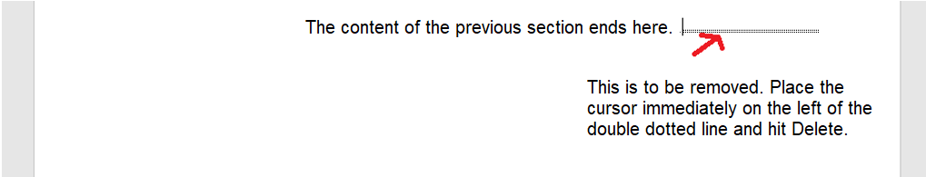
Figure 2. Removal of a section break.
.

Title of the Appendix
Content of the appendix is placed here

